CLOTHES
Препоръчваме да се преподава след Unit 2 (Energy for Bulgaria 5th grade) - Focus 1

Vocabulary: Clothes

Exercise 1 <track 2-04> Listen and repeat. Which words are in the photos?
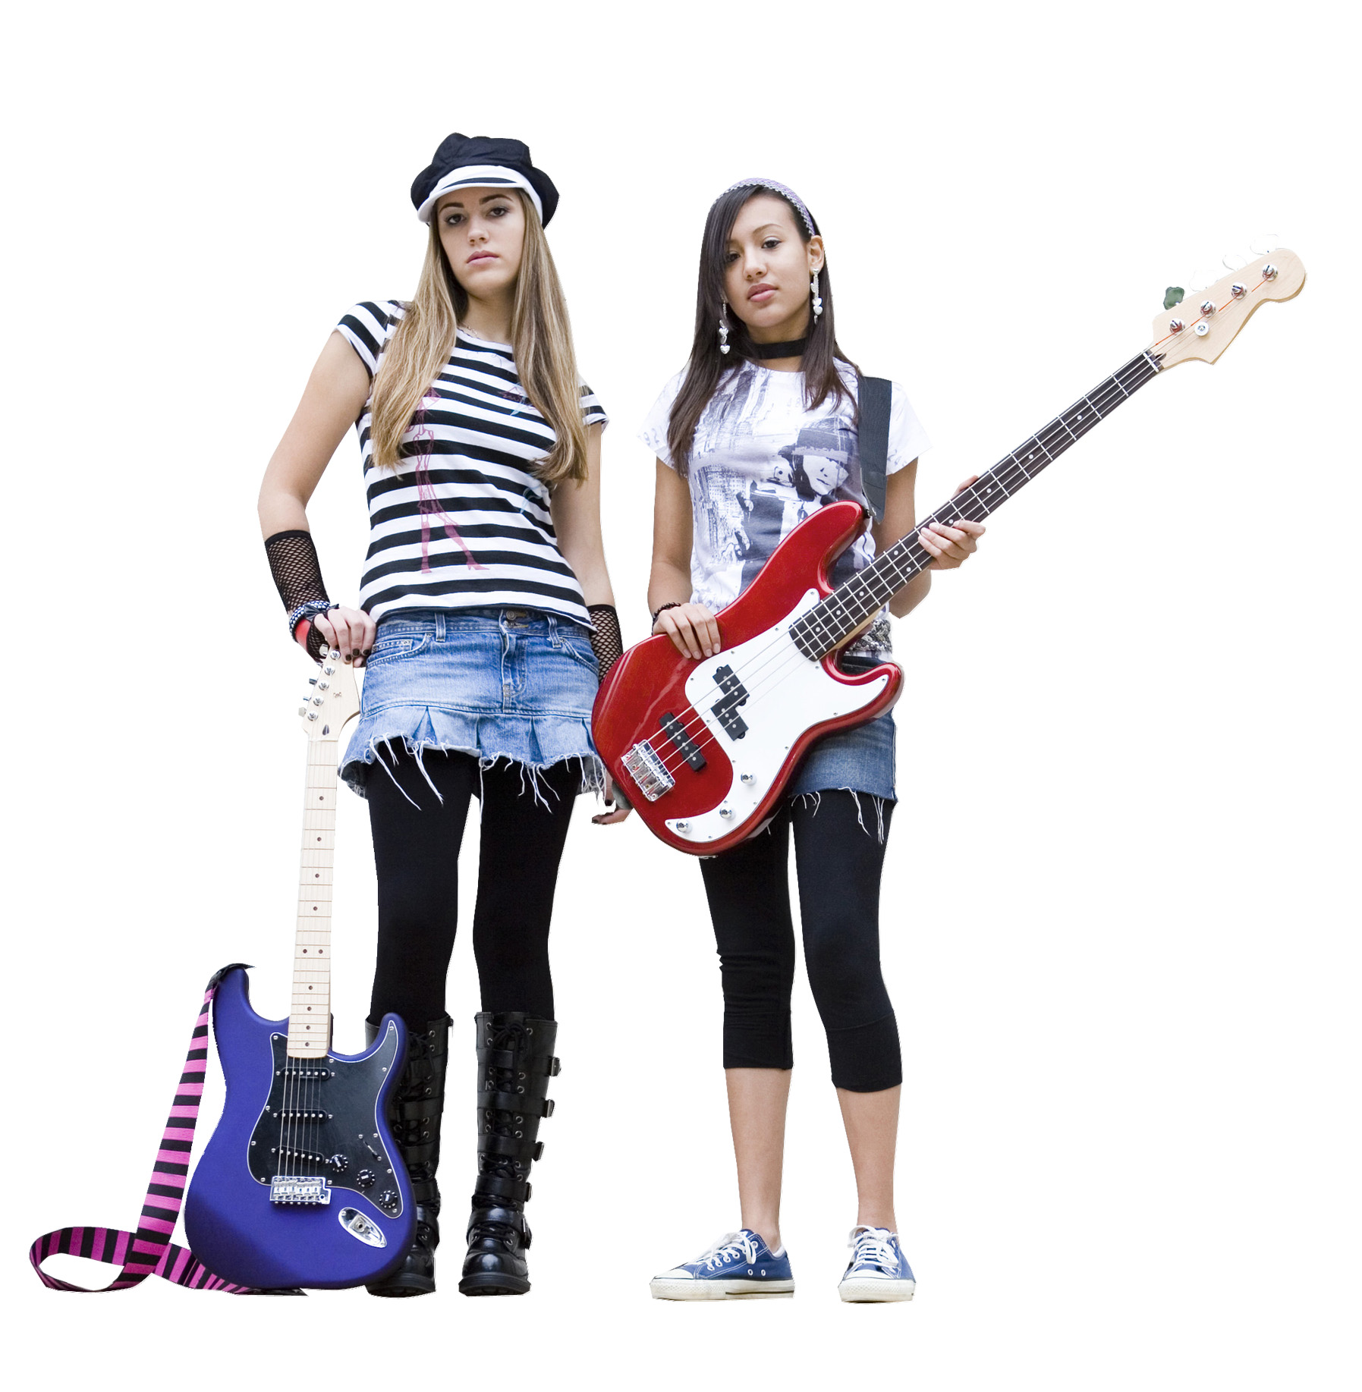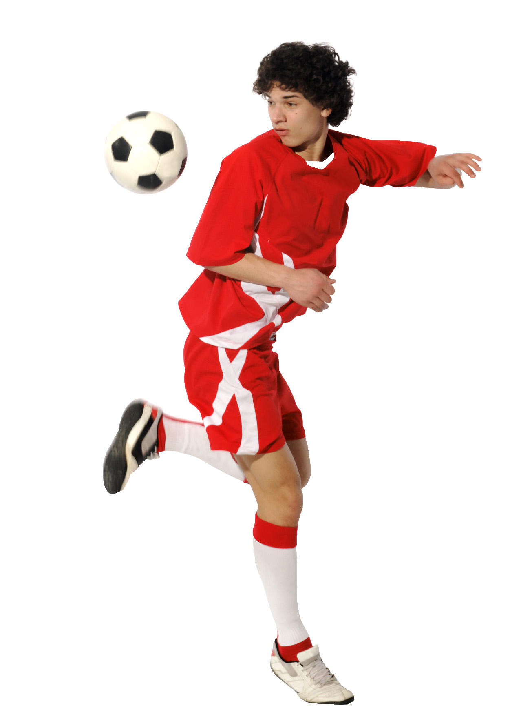
• boots • dress • gloves • hat • jacket • jeans • leggings • shirt
• shoes • shorts • skirt • socks • trainers • trousers • T-shirt

boots

Read

Exercise 2 <track 2-05> Listen and read. Which clothes words are in the article?

Our Questions
Your Answers
This week our questions are:
- What’s important in your life?
- What are your favourite possessions?
Now read two teenagers’ answers.

Family, friends and sport are very important in my life. My parents’ favourite sport is tennis. But my brother, Max, and I are crazy about football. We’re in our school football team. What’s my favourite possession? It’s my laptop. It’s fantastic for games. Kasabian is my favourite band. Their new album is on my laptop. My second favourite possession is my Barcelona T-shirt. Barcelona is my favourite team.
Adam – age 12

Music is very important in my life and my favourite possession is my guitar. It’s red and white and it’s great. In this picture I’m with my best friend, Ellie. I’m in blue and white trainers and she’s in black boots and a black and white hat. Ellie’s clothes are always so cool! We’re in a band. The band’s name is Stripes. It’s really good!
Rosie – age 13

Comprehension

Exercise 3 Read the article again. Find the answers (a–f) to questions (1–6). Then say Rosie or Adam.
1 What’s your favourite sport?
f) Adam
2 What’s your best friend’s name? a) Ellie d) My guitar
3 What’s your favourite possession? b) Music e) Barcelona
4 What’s your favourite team? c) Kasabian f) Football
5 What’s important in your life?
6 What’s your favourite band?

Speak
Exercise 4 Talk about you. Interview your partner for a magazine. Use the questions in Exercise 3.
A: What’s your best friend’s name?
B: Paola.

Exercise 5 Read the article again. Notice the words in bold.

Practice
Exercise 6 Write complete sentences with the genitive ’s or the genitive s’.
1 That’s/Joey/new shirt That’s Joey’s new shirt.
2 What’s/your sister/friend called? _____________________________
3 This is/my parents/old laptop. _____________________________
4 Where’s/Oliver/jacket? _____________________________
5 These are/Josie/boots. _____________________________
6 He’s/Mr Brown/favourite student. _____________________________

Vocabulary: Colours

Exercise 7 <track 2-06> Say the colours. Then listen and repeat.
• beige • black • blue • brown • gold • green • grey • orange • pink • purple
• red • silver • white • yellow

Exercise 8 Read the dialogue. Whose is the white Spike Girls bag?
Mary: Whose radio is this?
Ben: It’s my parents’.
Mary: The roller skates are cool. Are they yours?
Ben: No, they’re my sister’s. But the football is mine.
Mary: Hey, what’s this? A white Spike Girls bag. How sweet! Is it yours, Ben?
Ben: Mine? Are you mad? It’s my mum’s.

Exercise 9 Read the dialogue in Exercise 8 again. Notice the words in bold.

Practice
Exercise 10 Ask and answer.

1 book/Tom/my
Whose book is this? Is it Tom’s?
No, it isn’t his. It’s mine.
2 sunglasses/your brother/my dad
3 house/your grandparents/our
4 towel/Sara/Jake
5 DVDs/your/her
6 earrings/Katy/my

Listen

Exercise 11 <track 2-07> Listen. Which things are important in Georgia’s life?
friends school family music sport
possessions clothes animals

Write

Exercise 12 Write a paragraph about the important people and things in your life. Use the magazine page to help you.

Еxtra practice

1 Complete the sentences with the correct words.
1 Is this your sister’s/sisters’ dress?
Is this your sister’s dress?

2 Are those your friend’s/friends’ trousers?
_____________________________

3 Is that Tom’s/Toms’ house?
_____________________________

4 This is my parents’/parent’s car.
_____________________________

5 These are my favourite band’s/bands’ CDs.
_____________________________

6 Those are my brothers’/brother’s trainers.
_____________________________

